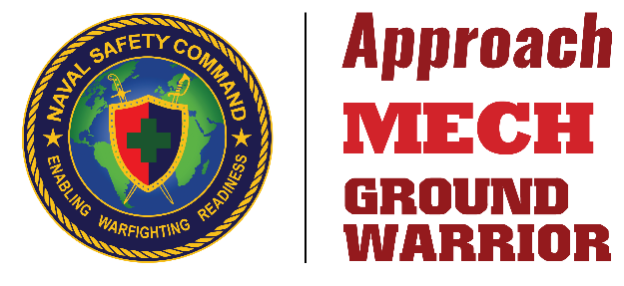
Your submissions help others manage their risk and maintain mission readiness!
Title: Proposed headline, subject to change.
Author: Rank, first and last name, unit, squadron or organization.
Article: Authors should fact check and ensure statements are backed by references or sourced data. Spell out acronyms on first reference. Include and spell out all organizations and units, city, state or country. Authors should ask a team member and/or subject matter expert to review article before submitting. NAVSAFECOM and/or CMC SD will make additional changes for clarity and style during the review process. Article length should be 450-1600 words.
Photos: All photos must be sent as separate files (not included in a word doc) and approved for public release. Images should adhere to established safety and security policies. Images should be the original with minimum 1 MB file size. Include the description, photographer’s rank and full name, unit or organization, location and date taken.
Bravo Zulu: BZ submissions should include details about managing risks or a near miss. Include the Rank, first and last name, unit, squadron or organization. Length should be 90-150 words and include a photo.
Send word doc and images to:
NAVSAFECOM_Approach@us.navy.mil | NAVSAFECOM_MECH@us.navy.mil | GroundWarriorMagazine@usmc.mil

Author Full name:
Unit / Squadron:
Nickname:
Aircraft or Equipment:
Article Location:
Image Keywords:
Magazine:
Notes to the Editors:

Title
Author
Article

